Ibizan Hound Club of the United States
Meg Smith,
IHCUS Secretary
1788 Rosewood Lane
Elkins, AR 72727
IHCUS Nomination by Petition Form

In accordance with IHCUS Bylaws Article IV Section 4.b Nominations, this nomination by petition is submitted for Board Term 2021-2022. Nominations must be received by the IHCUS Secretary no later than March 20, 2021
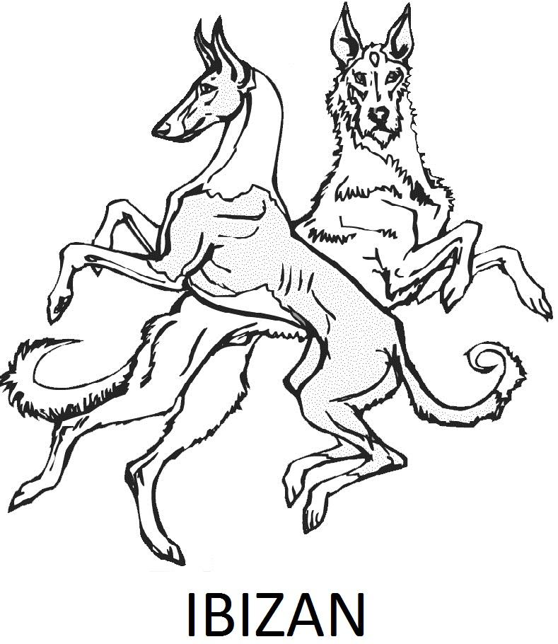
Name of Nominee _ ______________________________________ | State__ __________
Position being nominated for President Vice President Treasurer
Corresponding Secretary Recording Secretary Board Member
Signature of Nominee signifying willingness to be a candidate:  ________________________________________________ | Date__ ___
Signatures of Three Members in good standing:
- First Member Signature _______________________________________ | Date__ ___
Printed name :___ ___________________________
- Second Member Signature _____________________________________ | Date___ ___
Printed Name:___ ___________________________
- Third Member Signature _______________________________________ | Date__ ___
Printed Name:___ ___________________________

This form must be received hard copy with original signatures by the IHCUS Secretary no later than March 20, 2021 in order for a nominee’s name to be placed on the ballot for the IHCUS 2021-2022 Board Term Election.
Address: Meg Smith, IHCUS Secretary, 1788 Rosewood Lane, Elkins, AR 72727

Responsibilities specific to Board Members are outlined in the IHCUS Constitution, Bylaws, Standing Rules, and Roberts Rules of Order Newly Revised. Board business is conducted via the IHCUS online Board Forum and via the monthly Board meetings conducted by teleconference. All lHCUS Board members are expected to participate using these Medias.
Nominees are invited to submit a resume/bio to be mailed out with the election ballots to the membership. This resume/bio must be received by the Secretary no later than March 20, 2021 in a printed (not hand written) format, e-mail preferred, suitable for duplicating on a printer and may be submitted with this nomination form or by e-mail to “secretary@ihcus.org”.

